**Ideation Phase**

**Empathize & Discover**

|  |  |
| --- | --- |
| Date | 18 September 2022 |
| Team ID | PNT2022TMID04029 |
| Project Name | Gas leakage monitoring and alerting system for industries |
| Maximum Marks | 4 Marks |

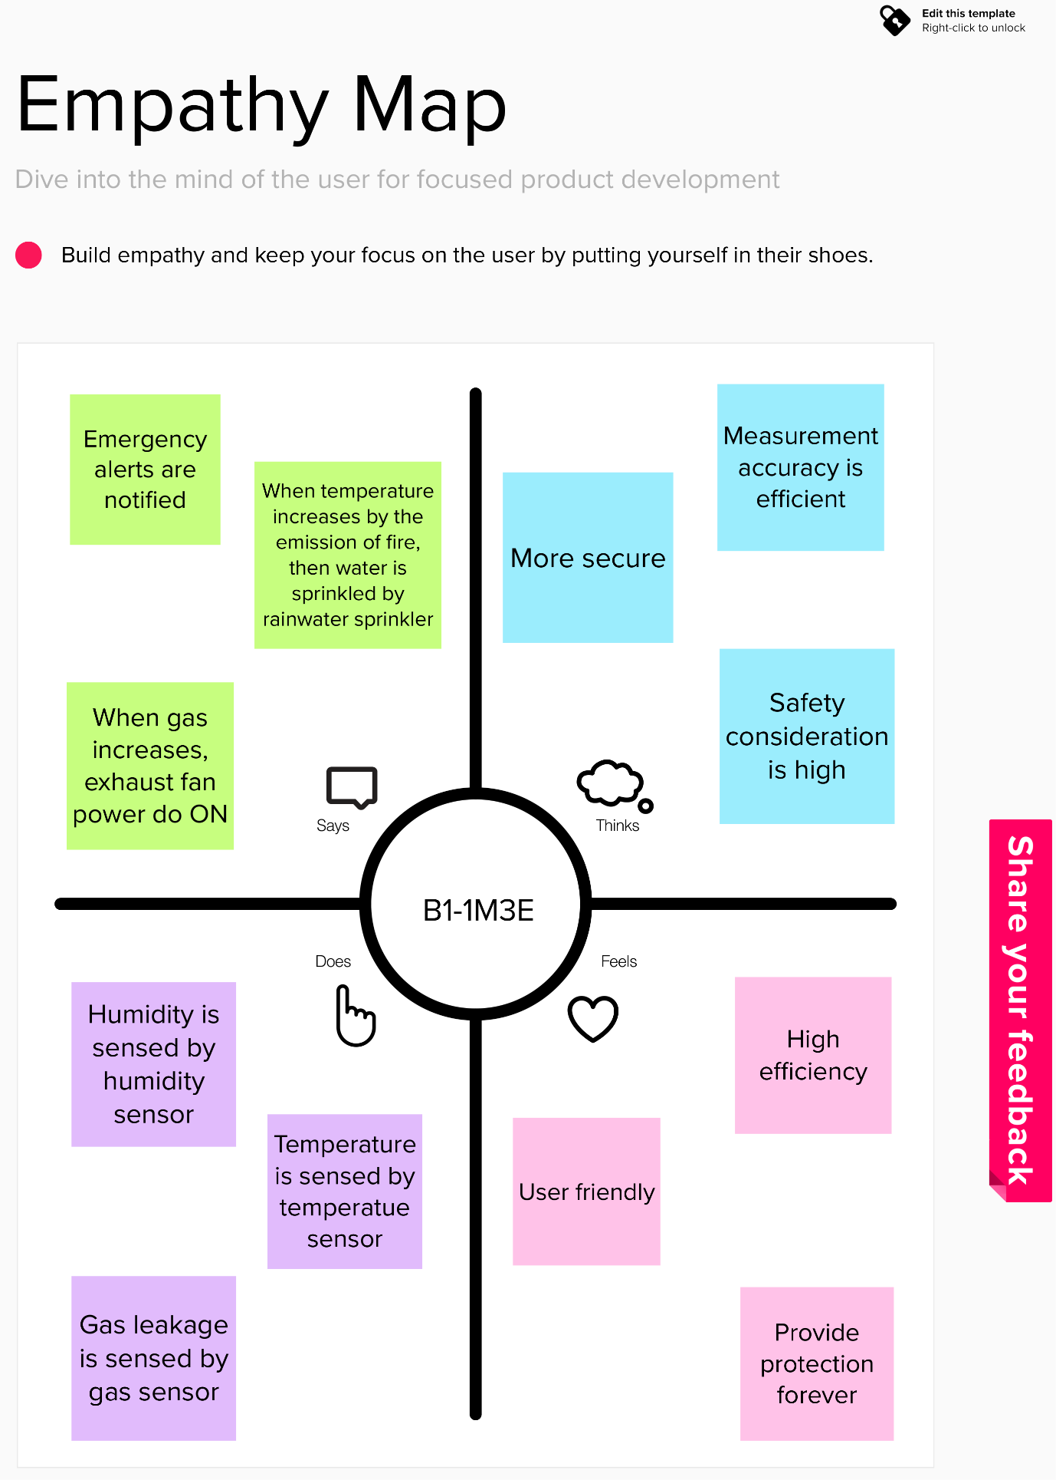

PNT2022TMID04029